BUS5CA Customer Analytics and Social Media

Assignment Number : 2
Assignment Submission Date : 8-10-2018
Submission by : Laeeqa Begum
Student ID : 19256512

Table of Contents
Introduction 3
Business Decision 3
Data set 3
Task 1 3
1. Key Demographic-Based Segments 3
2. Mapping Profiles into Roy Morgan Segments 5
3. Clustering and Segment Profiling 6
I) Without any Filter 6
II) With YES Subscribed 9
III) With No Subscribed 11
4. Difference in Segments for Customers Subscribed/Non- Subscribed to Long Term Deposit 13
TASK 2 14
1. Key Behavioural- Based Segments 14
2. Clustering and Segment Profiling 15
I) Without Any Filter 15
II) With YES Subscribed 17
III) With NO Subscribed 18
3. Difference in Segments for Customers Subscribed/Non- Subscribed to Long Term Deposit 20
TASK 3 21
Cross-cluster analysis – demographic to behavioural segments 21
Business Application of Clustering 21
II) Cross Cluster Analysis Using R 22
III) Lift Analysis by Excel 27
TASK 4 29
Customer segmentation based on combined Demographic and Behavioural data 29
1. Key Segments 29
I) With Out any Filter 29
II) With YES Subscribed 32
2. Different segments and profiles identified 35
Conclusion: 36
References 37

Introduction
Customer segmentation is very simple concept. It basically deals with dividing the customers into groups that share similar characteristics. There are many ways in which customers can be segmented however, the best one depends on the business objective. Which means there is no one way to perform customer segmentation. Here, we have challenge to do analysis on bank data.
We use clustering in customer segmentation as it creates groups. Basically, it includes input variables in the cluster analysis so that the cluster can be interpreted in the output variable.
Business Decision
The manager of Bit Bank conducted an analysis on existing customers who are involved in direct market campaign for inbound and outbound calls. Being company’s manager, he designed a project aiming on cluster-based customer segmentation and profiling which helps to give insights on consumer insights. As an analyst our main task is to analyse historical data and develop a predictive model for marketing purpose.
Data set
The data set consists of 45212 observations with 8 variables Age, Career, Education, Martial status, Mortgage, default credit, personal loan and subscribed.

Task 1
Market can be segmented to reach the customers for different product and services which include demographic segmentation, behavioural segmentation, psychographic segmentation and geographic segmentation.
In task 1 we consider customer segmentation based on demographic data. The characteristics included age, career, marital status and Education. The age varies from 18 – 95 with career involved in 11 fields related to student, admin, management, blue collar, technician etc. Their marital status differs from single, married and divorced. The education level varies from primary, secondary and tertiary.

Key Demographic-Based Segments
By demographic it is categorised into Age, Income, Ethnicity, Education, Social Class, Religion, Nationality, Occupation, Gender, Family Life cycle, Education.
The key demographic segments included in our Bit Bank data set are age, career, marital status and education. This effects customers what they want or buy or interested in.

Career:
It is most applied cue and define individual we meet. Once career provides status and income. It also directs one’s value, lifestyle, and all consumption process. There are 11 career options in this dataset with frequency.
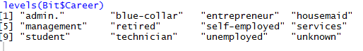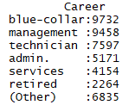
Education:
This sector has increased during 90’s with university degrees. They are very less unskilled as the training is increasing. Above 51% have high school degree and 30% completed their college. It is becoming hard for family wage jobs for education
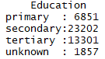
Age:
The main aim of the bit banker is to target the existing customers for their long- term deposits. The ideal age for targeting would be 30 – 50 years and the education level various from university, high school and professional courses with job holding in Admin, blue- collar and technician. Long term deposits usually offer higher interest rate than the short term. Age range from min 18 to maximum 95 in the dataset.
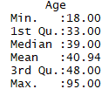
Marital Status:
Gender and marital status plays a huge impact on the on the financial picture. When compared to single, married persons focus more on returns. When a person is single/divorced/ married have considerable effect in long term planning. In our dataset the frequency of married is high followed by singles.
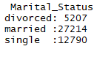

Mapping Profiles into Roy Morgan Segments
Roy Morgan value segments are of 10 types. As our demographic segmentation consists of age, marital status, career and education we try to map our data with it. Following graphs have been drawn while mapping.

Clustering and Segment Profiling
Variable importance is calculated using SAS enterprise miner. It helps to rank the variables in order based on their impact on model.
When we explore the demographic variables, there are no missing values or unusual values in the dataset. The variable subscribes is considered here as target variable hence selected as target. We do not apply any filter and make observation as how each variable has an impact in each segment.

Without any Filter
- After selecting our dataset, we explore our input data without target variable
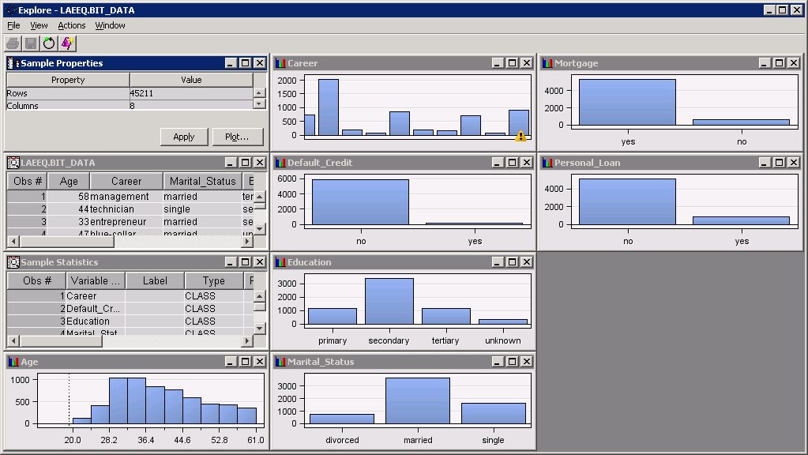

- Then we connect the filter node to the data set node. In property tab class interval, we try to view interactive class filter by class variable and changing default filtering method to none.
In this we do not apply any filter and its default
- Connect cluster node to filter node and changing the property tabs and editing the variables as below. We view are result after run of the cluster node
There are four windows in the result segment plot, segment size, statistics and output. 5 clusters are created as we have given 5. Each segment size plot shows segment ID with their cluster frequency. Segment 4 has highest cluster frequency.
The frequency of cluster can be found from mean statistic plot which shows that it varies from 751 to 15013.
From the output plot we can observe the variable importance which is calculated by SAS decision tree. It shows the overall importance of each variable in the fitted tree. Age is having higher importance than career. We can say that Age is having higher impact in the model.

Variable Importance based on Cluster
Segment with Variables worth and their effect on the particular segment.
Segments | Age | Education | Career | Marital status
1 | 0.417 |  | 0.011
2 | 0.329 |  |  | 0.013
3 | 0.251 |  | 0.027 | 0.011
4 | 0.443 | 0.013 | 0.030 | 0.074
5 | 0.032

From the above analysis we can say that, age of the customers has a greater influence on the Bit bank. If the bankers want to do inbound or outbound calls for long term deposits their first target need to be the age of the customer which can be followed by marital status.
By Connecting Segment profile to Cluster Node.

Variable Importance based on Segments
In the profile, segment 4 is having high percentage. The main variables observed are age followed by marital status, career and education.
Segment 1- Age and Career; Segment 2- Age and Marital status ; Segment 3 – Age, Career and Marital Status and last Segment 5 - Age

With YES Subscribed
To the source filter node is added and in the property column the class variable is selected with default filtering method user specified. The result is obtained with Target Yes and number of observations.
When cluster node is added with maximum cluster specified to 5, specification method to user specified and internal standardisation to none. Following results are obtained after run
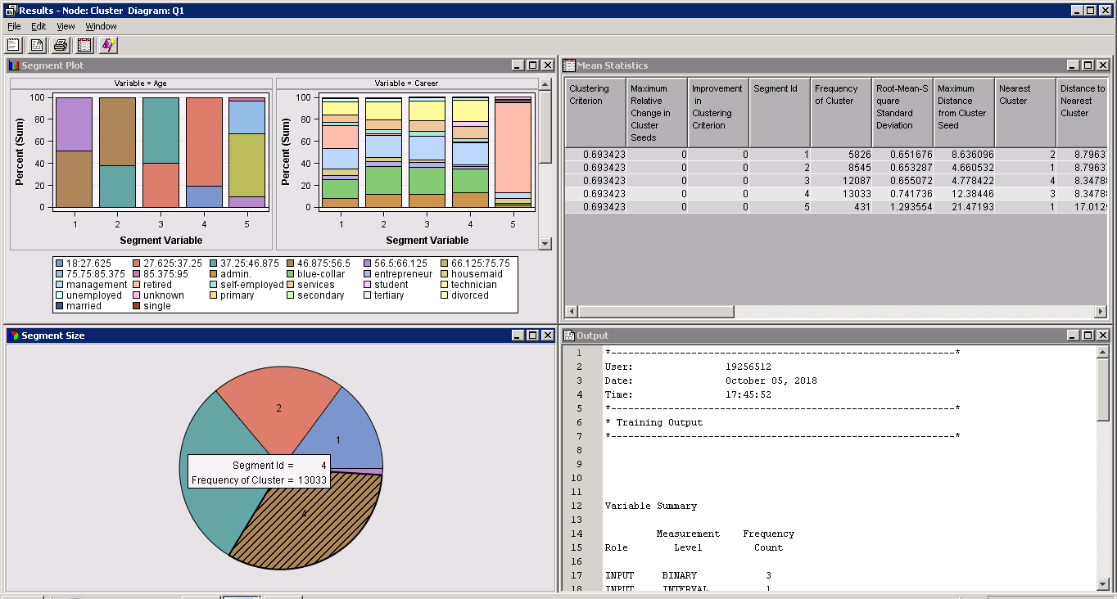
We can observe that segment plot gives various distribution of variables, segment size gives number of clusters, Mean statistics show us the cluster frequency which varied from 431 to 1303. The output is give us the variable importance.

Variable Importance based on Cluster

From the above subscribed, the variable with high importance is 1. Career having less impact on age holding importance 0.82 which is close to 1. Marital status and Education are also impacting the model because they are not 0.
When Segment Profile is added to the cluster node respective variable edits are made by selecting the demographic as yes, behavioural as no and rest as default. Then we analyse the result by run

Variable Importance Based on Segments
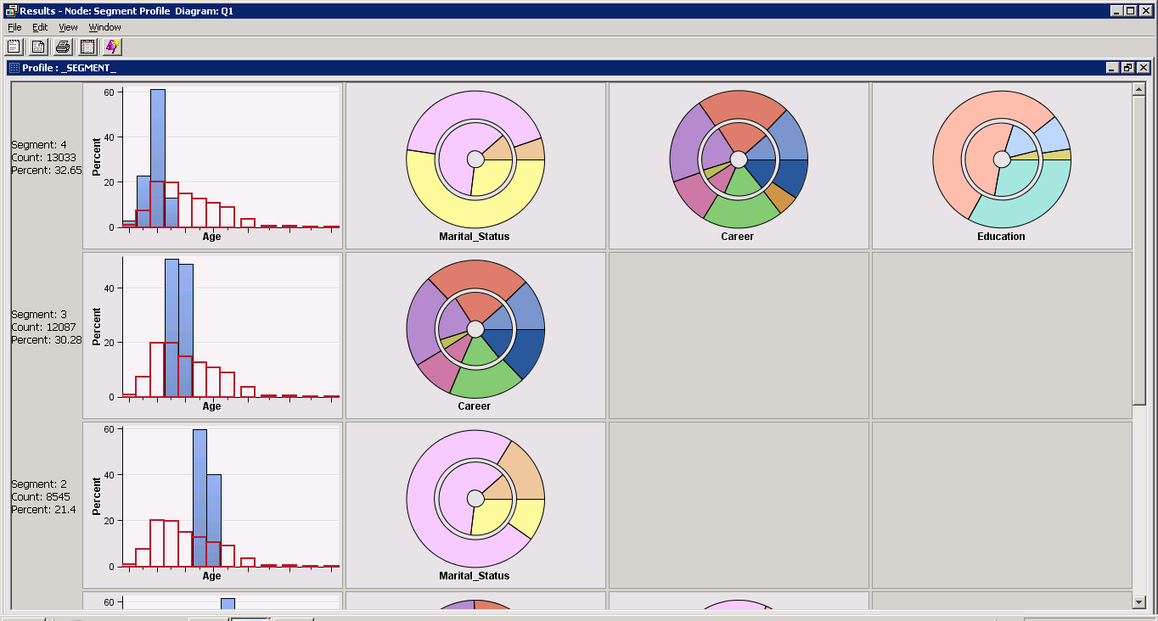
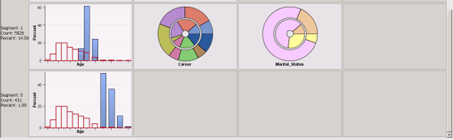
We observe that
Segment 4 has high frequency count and percentage. The profile age, martial status, career and education are their in the cluster.
Segment 3 has Age and career , Segment 2 has Age and marital status, segment 1 has age career and marital stats and segment 5 has age.

Decision Tree Importance Profile

This gives us the complete information about clusters, frequencies, Variables worth and their rank in respective segment.

With No Subscribed
To the Dataset node, filter node is added and in the property column the class variable is selected with default filtering method user specified. The result is obtained with Target No and number of observations
When cluster node is added with maximum cluster specified to 5, specification method to user specified and internal standardisation to none. Following results are obtained after run 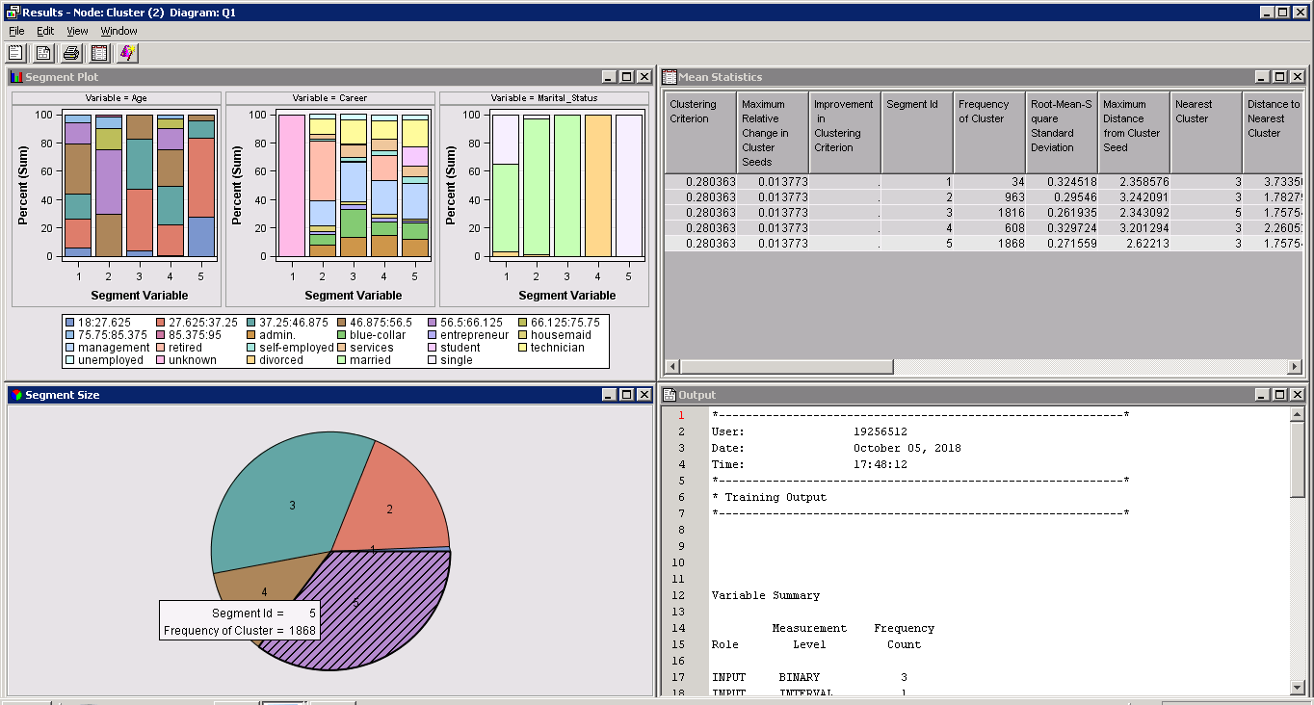
From the result window we observe that, the segment 5 is having highest frequency of clusters. The mean statistics shows that the frequency of clusters varies from 34 to 1868.

Variable Importance based on Clusters
The Variable age is having highest impact on the model followed by marital status and career with little difference in between them.

Variable Importance based on Segments
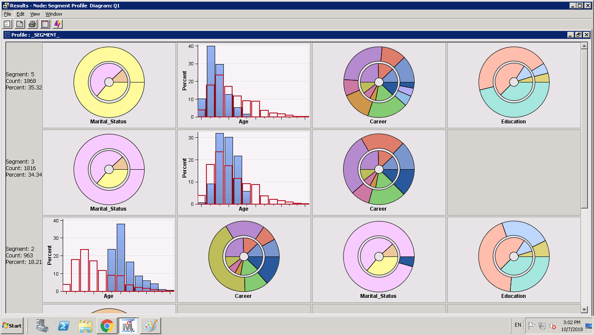
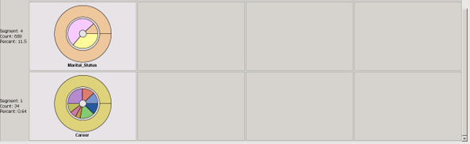
From the above we observe that segment 5 has highest percent and frequency count compared with all other segments. Variable marital status impacting highest to the model followed by age, career and education. Segment 3 has next impact by the variables marital status, age and career. In segment 2 age is having the impact to that segment followed by career, marital status and age, in segment 4 its marital status and in segment 1 career.

Decision Tree Importance Profiles

From the above we can observe that segment 5 is impacting the model with high frequency count and total frequency. Overall variable marital status is high followed by age. The least impacting is the education. Highest worth of marital status is 0.44.

Difference in Segments for Customers Subscribed/Non- Subscribed to Long Term Deposit
 | Subscribed | Non-Subscribed
HIGHEST PROFIT SEGMENT | Segment 4 | Segment 5
 | In this segment the most impacting variable was age worth 0.43. Because of customers age bank called the account holders for long term deposits. Second importance was given to marital status and then to career and education. | The bit bank didn’t call or give subscription based on marital status which hold a worth of 0.44, it also observed age, career and education main criteria for not subscribing.
HIGHER PROFIT SEGMENT | Segment 3 | Segment 3
 | In this segment also age 0.422 worth was given importance. Followed by career, marital status and education | In this segment also, marital status was having hold on top list with a worth of 0.21. Likewise, age was second reason for not subscribing later career and education.
MEDIUM PROFIT SEGMENT | Segment 2 | Segment 2
 | In segment 2 age was the main reason for outbound and inbound calls for long term deposits. The second rank was marital status, third career and last education. | In this segment age was the target for not subscribing for long term deposits as it was holding higher rank when compared to other variables in the segment like career, marital status and education.
LOWER PROFIT SEGMENT | Segment 1 | Segment 4
 | Age was the main target at the lower level as well for the bankers to call for customers. Followed by career, marital status and education | Subsequently, in this segment marital status worth 0.19 was the main reason followed by age, career and education which were ranked 2,3,4th in the list.
LOWEST PROFIT SEGMENT | Segment 5 | Segment 1
 | In this segment also age was the first preference with worth 0.02 followed by career, education and marital status. | This was the lowest frequency count cluster with variable career impacting most the model. This was also one reason for not subscribing for long term deposits.

TASK 2

Key Behavioural- Based Segments

Behavioural segmentation is an important part of segmenting the customers according to their behaviour and attitude towards the product. The key behavioural variable in the data are Default Credit, Mortgage and Personal Loan.
Default Credit:
The Default credit consists of all the negative listing and which will be on file for a certain period of time. In our case study Bit Bank the employee should not encourage the customers for long term deposits who are on default list through inbound or out bound calls.
Total number of customers 45211 out of which 815 are on default credit list. The customers who are subscribed and are on default list are 52. With maximum group married and single with secondary education. Holding career in blue collar, management, technician.
Mortgage:
In Bit bank the customers who are on mortgage are 20717 and among them who have been subscribe for long term deposits are 1235. Basically, these customers hold secondary education and with high percentage of marital status married.
Personal Loan:
The number of customers who under took personal loan from Bit bank are 6426 and among them who are subscribed for long term deposits are 339. The major chunk are married followed by single marital status.

Clustering and Segment Profiling

Without Any Filter
The data set was prepared same as Task 1 only difference was behavioural variables were considered.
Dataset node connected to filter node, in class intervals select the iterative class filter.
By Connecting the cluster node and properties same as Task 1, by editing the variables the result observed is

Variable Importance by Cluster
This shows that Mortgage is having higher importance.
By connecting the segment profile node and changing the property minimum worth to 0.001 the result obtained is
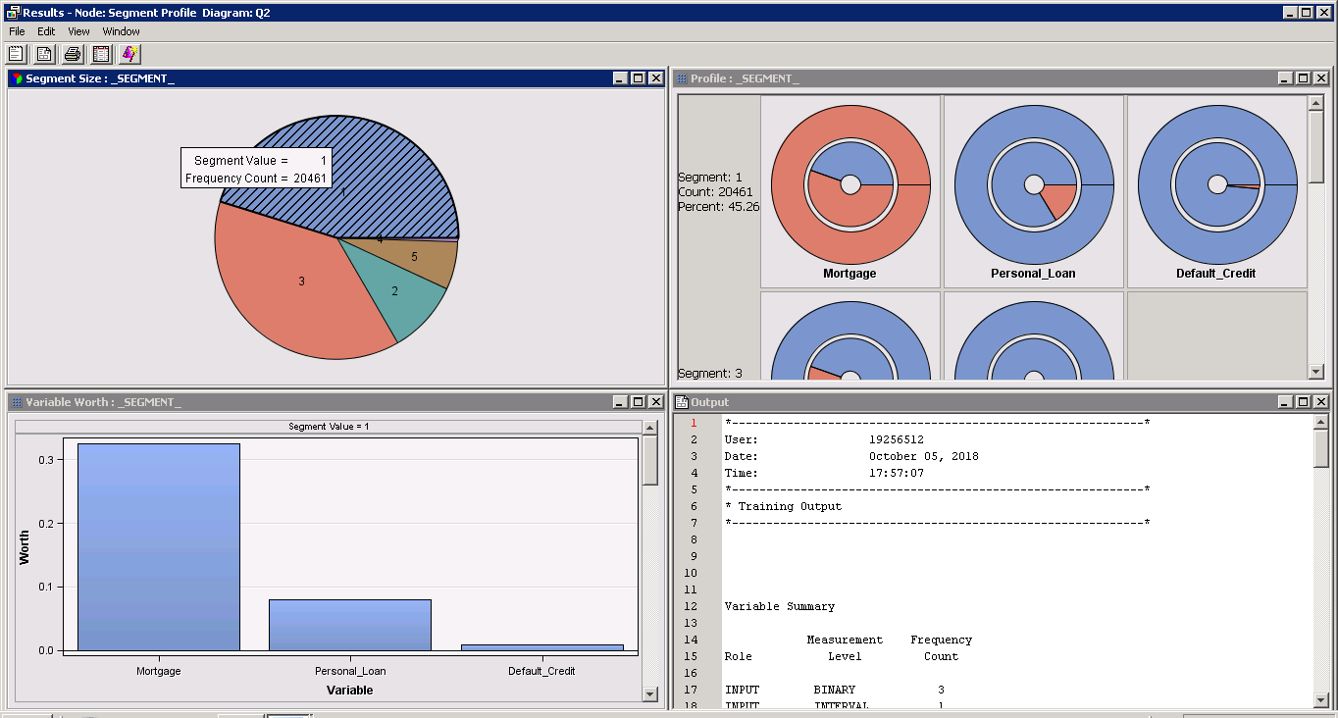
In this Segment 1 is having high frequency count.

Variable Importance by Segments
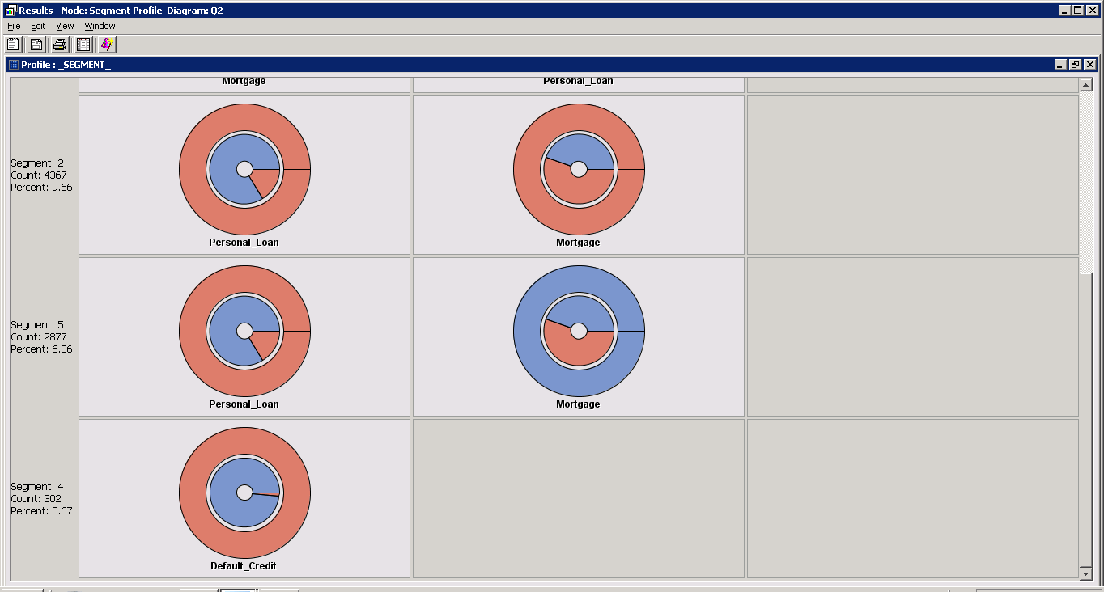
From the above we observed that Mortgage has the highest impact on the model followed by personal loan. Segment 1 has the most frequency count compared to others.

With YES Subscribed
- In filter node property class interval we edit the variables and select the behavioural variables. With Subscribed variable to Yes. And following observations are recorded below.

- In the next step we apply cluster node
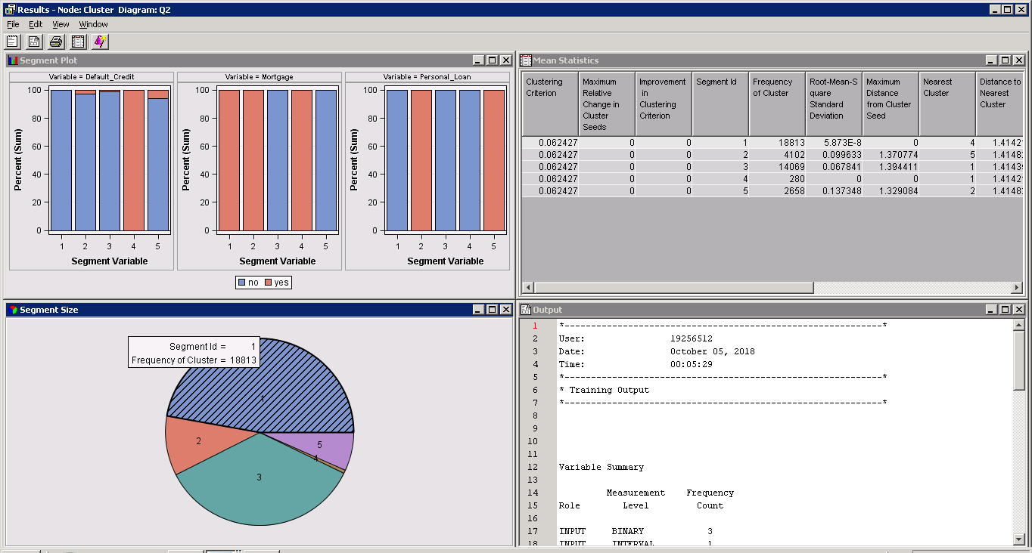
The result shows that segment 1 has high frequency count with frequency of cluster varying from 280 to 18810.

Thus, the output obtained is

Variable Importance by clusters

The cluster variable importance is see with 1 or close to 1 but not 0. If its completely 0 we need to remove that variable. But from the above we can assure that Mortgage and Personal loan are given high importance when subscribed to YES with least importance to default credit.

Decision Tree Importance Profile
From the above we analyse that Segment 1 is having high frequency with 47.12% and the variable impacting the model is Mortgage with 0.31 worth. Followed by personal loan. Segment 3 is the next impacting cluster with mortgage being key variable.

With NO Subscribed
The data set is attached to filter node and following observations are recorded
Cluster node is connected and following observation is taken
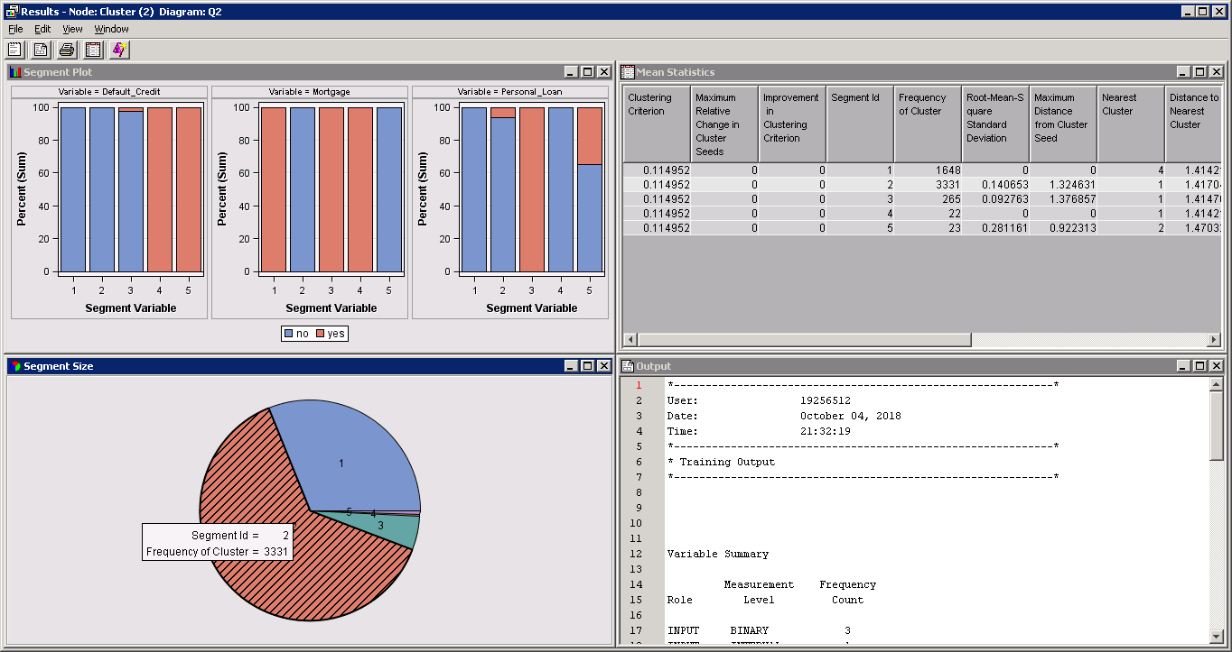
From the above we analyse that Segment 2 is having the highest count and the frequency of clusters varies from 22 to 3331.

Variable Importance by Clusters
From the above we can observe that variable Mortgage is the most frequent occurring variance and followed by personal loan and default credit close to 1.

Variable Importance by Segments
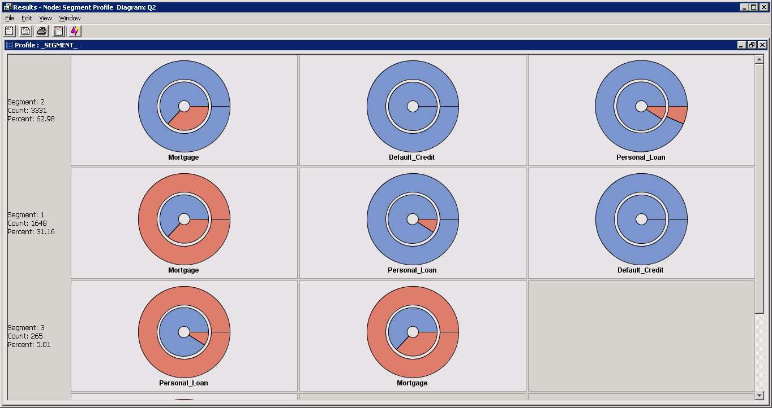
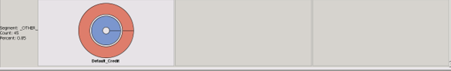’
From the above segment analysis we can observe that Segment 2 is having high impact followed by segment 1 and segment 3. The most important variable in the segment 2 and 1 is Mortgage.

Decision Tree Importance Profiles
From the above we observe that only 3 clusters are visible as the frequency count is too less the other segment tend to be combination of segment 4 and 5. The highest frequency cluster is 2 with the variable Mortgage impacting the most.

Difference in Segments for Customers Subscribed/Non- Subscribed to Long Term Deposit
Segment | Subscribed | Non-Subscribed
HIGHEST PROFIT SEGMENT | Segment 1 | Segment 2
 | This cluster has the highest frequency count and the important variable impacting is Mortgage. Because of mortgage the bank is preferring customers for subscribing for long term deposits. Next important variable is personal loan and last one default credit. | This segment is having highest frequency count and the percentage of customers are high in this segment who are having high mortgage followed by default credit and personal loan. So it’s, advisable that Bank undertake following behavioural aspects before subscribing customers for long term loans.
HIGHER PROFIT SEGMENT | Segment 3 | Segment 1
 | Mortgage worth is high and is ranked 1st in that segment. Followed by personal loan and default credit. | Mortgage is the impacting variable in this segment followed by personal loan and default credit.
MEDIUM PROFIT SEGMENT | Segment 2 | Segment 3
 | In this segment personal loan is impacting the segment and mortgage and default credit comes 2nd and 3rd in list. | Personal loan followed by mortgage and default are in rank wise in this segment .
LOWER PROFIT SEGMENT | Segment 5 | Other 4&5
 | This segment has personal loan with highest worth and next mortgage. | This segment is combination of two segments as there are few counts. Default credit is high in this cluster.
LOWEST PROFIT SEGMENT | Segment 4
 | In this segment default credit is given high preference, second to mortgage and then to personal loan.

TASK 3

Cross-cluster analysis – demographic to behavioural segments

Business Application of Clustering
Bit Bank used clustering to segment its customers into 5 different groups based on their Demographic and Behavioural data. Then it undertook customized marketing strategies for every segment to target the customers more effectively.
One of the group was Demographic that comprised of age, marital status, career and education. This emphasis on how many customers are loyal and willing for long term deposits, who they can target based on marital status and career.
Another group was behavioural which comprise of credit defaults, mortgage, personal loans. A marketing strategies was laid focusing on who in debit with bank.
They are two types of clustering based on data set which depends on bank performance and satisfaction of customers. In general, the two categorical based clusters are non-hierarchical and Hierarchical Clustering.

Cross Cluster Analysis Using R
As we load the dataset, we find the frequency of the categorical variables rather summary of whole dataset.
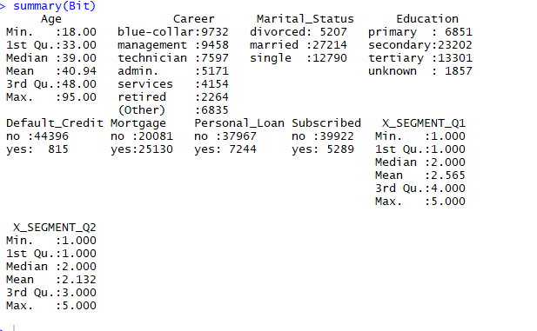

We try to explore our dataset by finding any missing values
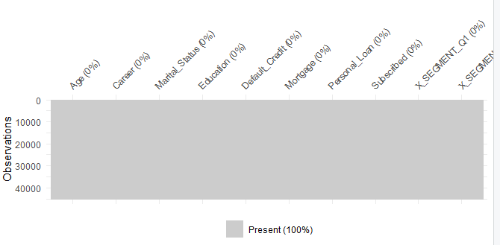
We create frequency tables to find the summaries of distribution of different values in the data set. It helps to create Univariant distribution.
Creating frequency table for both the segments in R
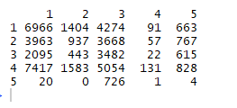
From the above we analyse that in each segment there are number of customers who have subscribed and not subscribed for long term deposits.
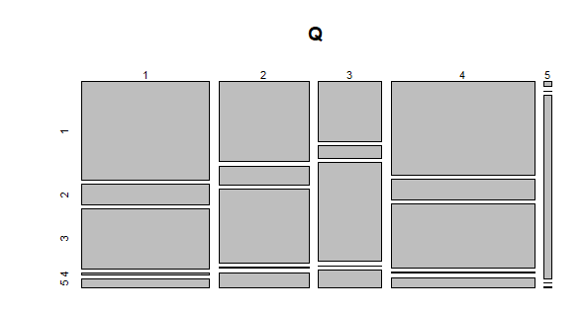
The next would be generating frequency through R
- We have summed over rows ie., Demographics to give us the total for each Behavioural column. The output result is stored in the Behavioural Matrix.
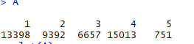
- We have summed over Behavioural columns to give us the total of each Demographic row. The result will be stored in the Demographic Matrix.
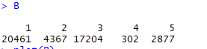
- Plots of A and B

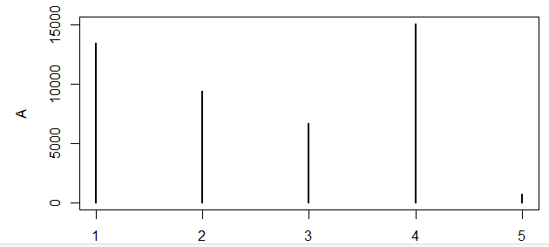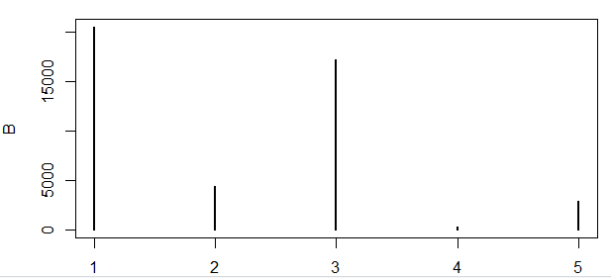
- The we use probability table function
This helps us to specify proportions with respect to different distribution of margins by using optimal argument.
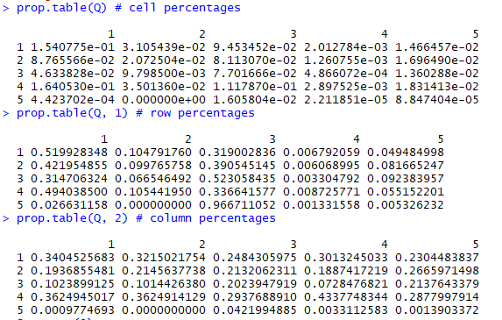
- Chi- square test helps us determine if the proportions are different. To find the 95% confidence level we consider summary
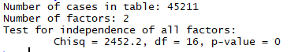
P value helps us understand if there is any difference between two demo and behavioural groups.
Results are significant where p value is nearer to 0. P value lie in between 0 and 1.
P value is 0 means P<0.001 we reject the null hypothesis.
We can assume that the Bit bank opinion on long term deposits are independent. Therefore, we can say that demographic and behavioural groups are dependent and there is association between them.
- When we add another dimension “subscribed”
We get the following count for the clusters yes and no
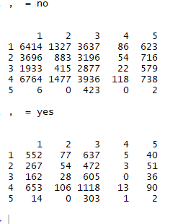
From the above we can analyse that, there are more customers who have not subscribed for long term deposits when compared to the one subscribed.
From the below plot we can visualize the customers subscribed and not subscribed in each segment for two groups.
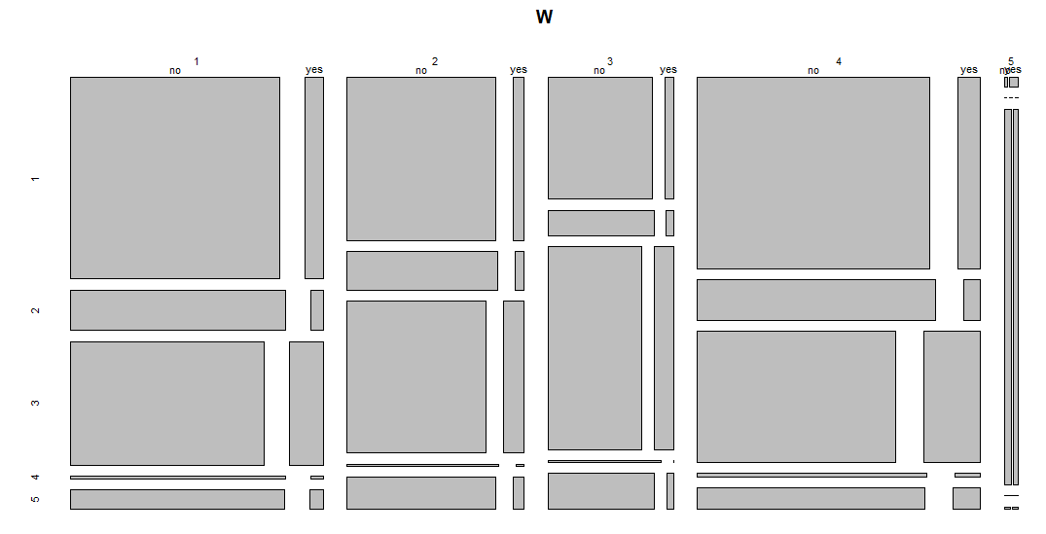
- We follow the same steps as above by adding an addition dimension for prob.table to find distribution of margin.
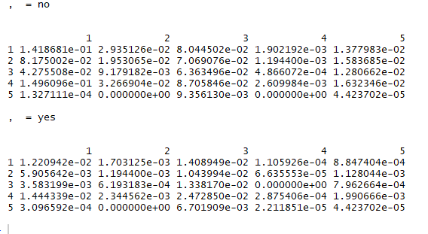

- 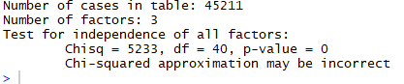

From chi square distribution we can say that Bit bank opinion on long term deposits are independent by targeting the subscribed . Therefore, we can say that demographic and behavioural groups are dependent and there is association between them. There is a strong relation between the two groups and the outcome(subscribed).

- When applying k- mean clustering , the result obtained is
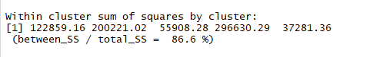

From the above we can say that, we get total_SS when we calculate sum of squared distance of each observation to overall samples.
As we have 5 clusters, we calculate 5 averages to the overall avg, we obtain between_SS.
86.6% is the total variance in the dataset which is explained by clustering.
- Then we analyse location of 5 clusters and also data point to which the cluster belongs.
- Comparison between two group clusters based on subscribed is shown below.
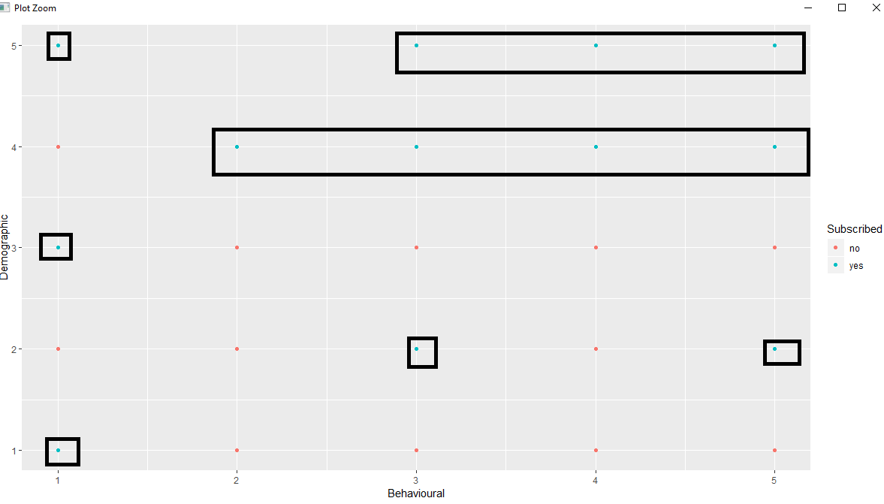

From the above we can say that the associations of demographic and behavioural with subscribed.
All the highlighted one are subscribed YES. In every cluster they are subscribed. But when similar clusters are grouped together show strong relation between them. Thus, we can say that Demographic Row cluster 4 has a strong relation with the subscribed.
- Best Cluster – Each iteration to display the Elbow graph
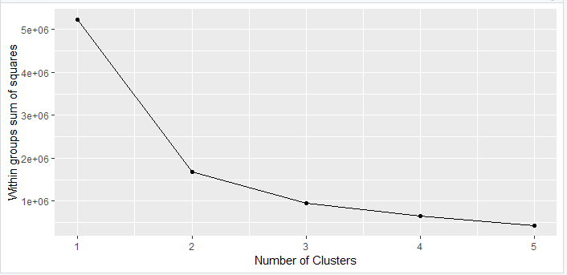
From the above we can see that around 2 and 3 there is decline. We can select 2 or 3 for our dataset.
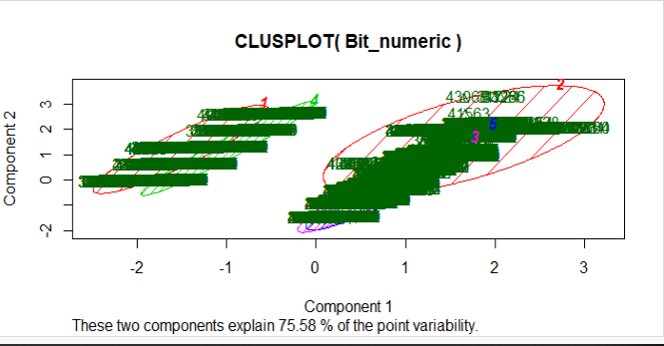

Point of variability is explained by two components. Model assumes variability partitionable into common and unique components. It reduces the number of variables in the dataset but try to match with the total variation in the original data set. The Principle component account for 75.58% of variability in the data

Lift Analysis by Excel

The csv files are generated with help of SAS for our analysis. We combined two dataset.
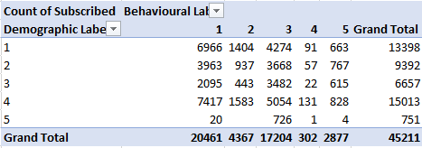
From the above table we can say that, the total number of observations are 45211. The highest count is in demographic row, segment 4. The highest count in behavioural column is segment 3.
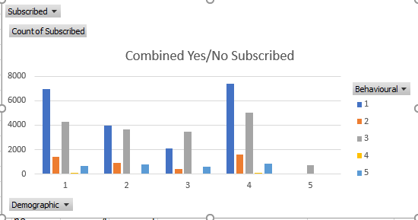
The graph shows the relation between demographic and behavioural with subscribed and non- subscribed customers.
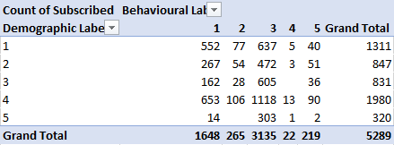
From the above subscribed data the total subscribed customers are 5289. The highest value is 1118. The highest count of demographic is 1980 and behavioural is 1648.
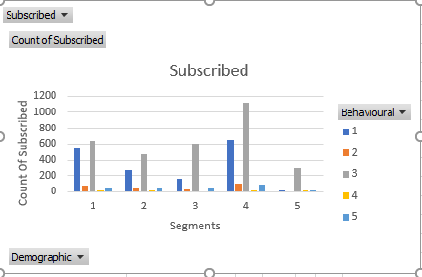
The lift is calculated by dividing the values of count of subscribed by the total count in combined.
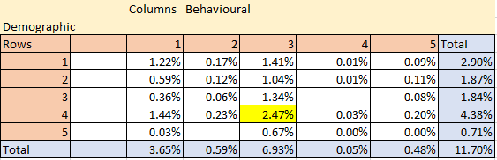
  - % is the lift value.

TASK 4

Customer segmentation based on combined Demographic and Behavioural data

Key Segments
In this task we conduct clustering and profiling on both the groups Demographic ( Age, Education, Career, Marital Status) and Behavioural (Personal Loan, Default Credit, Mortgage) together except the target variable subscribed.
- With Out any Filter:
- We select our data and edit variables by targeting our last column subscribed. We check the result after running
- Now we attach filter node to the data source node
From the property tab we select the class interval and visualize the iterative data without applying any filter and check the result after running.
- Now we attach cluster node to the filter node, change the property setting run and view result.

Variable Importance by cluster
- We attach Segment Node to the cluster node, make changes in property and edit the variables.

Variable Importance by Segments
From the result window of segment profile we can analyse the main profiles and their worth.
From the above we can analyse that Segment 4 has highest customer with 21.33% considering demographic feature age and career. When we look down to every segment we see that the age would be the most important criteria followed by marital status and career.

Decision Tree Importance Profiles
From the above we can say that Segment 4 is followed by 2,5,1,3 based on their importance. Each variable and its worth is specified with age carrying highest worth.

With YES Subscribed
- Data source is attached to filter node
From the property tab we select the class interval and visualize the iterative data with applying YES filter and check the result after running
From the above when we select yes and apply filter the target will be no, and it will be excluded from the data. The number of observations for filtered data is 5289.
- When we add cluster variable- our first step is to edit the variables, change the property with 5 cluster and internal standardization to none and view the result after run.

Variable Importance by cluster
From the result window we can see that in mean statistics window the frequency of cluster varies from 469 to 12761.
The variable importance after subscribed is Age which is equal to 1. Career and marital status are close to 1 and the other variables like education, mortgage, default credit and personal loan are equal to 0 which can be ignored.
- Segment node is attached to cluster node to know important profiles.

Variable Importance by Segment
From the above we can analyse that Age is given highest importance followed by career and marital status. The number of count in Segment 4seem to be high.

Decision Tree Importance Profiles
From the above we can say that the frequency count is high in 4th cluster and followed by 2 cluster. The important profiles in 4th segment are age 0.43 worth which is followed by career 0.01 worth, mortgage 0.004 worth, education 0.001 worth, marital status 0.0003 worth, default 0.00002 worth and personal which is equal to 0.
This segment has the highest impact when compared to all other segments in the subscribed.
Over all when we observe all the segments Age is ranked 1st followed by career 2nd.

Different segments and profiles identified
Yes, different segments and profiles are identified when compared with the third steps of task 1 and task 2.

Segment | Subscribed-Demographic | Subscribed- Behavioural | Subscribed- Combined
HIGHEST SEGMENT | Segment 4 | Segment 1 | Segment 4
 | In this segment the most impacting variable was age worth 0.43. Because of customers age bank called the account holders for long term deposits. Second importance was given to marital status and then to career and education. | This cluster has the highest frequency count and the important variable impacting is Mortgage. Because of mortgage the bank is preferring customers for subscribing for long term deposits. Next important variable is personal loan and last one default credit. | This cluster has the highest frequency count and the important variable impacting is Age. Career is ranked 2nd, followed by mortgage, education, Marital status, Default credit and personal loan.
HIGHER SEGMENT | Segment 3 | Segment 3 | Segment 2
 | In this segment also age 0.422 worth was given importance. Followed by career, marital status and education | Mortgage worth is high and is ranked 1st in that segment. Followed by personal loan and default credit. | Age is ranked 1st with highest worth, followed ranked wise marital status, career, education, mortgage, default, personal loan
MEDIUM SEGMENT | Segment 2 | Segment 2 | Segment 5
 | In segment 2 age was the main reason for outbound and inbound calls for long term deposits. The second rank was marital status, third career and last education. | In this segment personal loan is impacting the segment and mortgage and default credit comes 2nd and 3rd in list. | Age is holding constant and holding the highest worth, next are marital status, career, education, mortgage, personal loan and default credit
LOWER SEGMENT | Segment 1 | Segment 5 | Segment 1
 | Age was the main target at the lower level as well for the bankers to call for customers. Followed by career, marital status and education | This segment has personal loan with highest worth and next mortgage. | In this segment also, age is holding the highest worth followed by career, marital status, mortgage, education, personal loan, default credit.
LOWEST SEGMENT | Segment 5 | Segment 4 | Segment 3
 | In this segment also age was the first preference with worth 0.02 followed by career, education and marital status. | In this segment default credit is given high preference, second to mortgage and then to personal loan. | Age is holding and impacting this segment, next is career, mortgage, education, marital status, personal loan and default credit.

Conclusion:
SAS is an important machine learning which helps us give strong relationship between customers, risk management, target customers and give profit.
When we compare the combined data of demographic and behavioural to the individual sets there is a huge difference.
- Demographic is leading behavioural variables to target customers.
  - In this segments age is given the highest priority and by default it’s on top to low list.
  - Career and mortgage are on 2nd ranking but career is taking a lead followed by mortgage.
  - Education, marital status, default credit and personal loan are followed step by step.
- Frequency Count highest
Demographic – 13033, Behavioural – 18813, Combined – 12761
- Percentage
Demographic – 32.64%, Behavioural- 47.12%, Combined – 31.96%
A bell curve helps us understand the segmentation. Solved by R
We have 20% of scored customers who are willing for long term deposits- Solved by R and Excel.
p-Value help us understand the dependability of one group on to another. – Solved by R

References
CLASSIFYING BANK CUSTOMER DATA USING R? USE K-MEANS CLUSTERING. (2017). DEX lab. Retrieved from https://www.dexlabanalytics.com/blog/classifying-bank-customer-data-using-r-use-k-means-clustering
Stackoverflow. (n.d.). Retrieved from https://stackoverflow.com/questions/23203592/basic-clustering-with-r
WEI. (2018). Customer Analytics and Social Media. Melbourne. Retrieved from https://lms.latrobe.edu.au/course/view.php?id=55106

